Web adVERTISING INFORMATION & CONTRACT
NOTE: Ads that advertise parties/events/gatherings that occur during DC Black Pride are not eligible for Web advertising rates. To purchase a Web ad for parties/events/gatherings that occur during DCBP, a party promotion agreement must be established. For more information on party promotion email info@dcblackpride.org.

Ad SIZES & RATES

Type | Size | Cost | Location on site
Wide Skyscraper | 160 pixels x 600 pixels | $800 | right side of all pages
Leaderboard | 728 pixels x 90 pixels | $600 | at the top of all pages.
Medium Rectangle | 300 pixels x 250 pixels | $300 | right side of all pages
Rectangle | 180 pixels x 150 pixels | $100 | right side of all pages

All Web ads run in six (6) month increments.
SAMPLES (Visual representation, not full size)
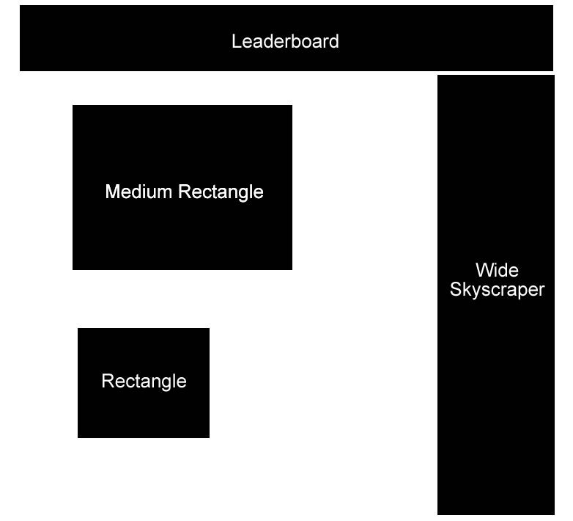

SPECIFICATIONS
Submitted ads must meet the following specifications to be posted. Ad design is not offered. Ads that do not meet specifications will not be posted.
- An URL to a working website must be provided with all ads.
- Ads will be posted as submitted, please proof ads before submitting.
- Acceptable formats: GIF, animated GIF, JPG, PNG.
- All colors saved in RGB for the Web.
- WIDE SKYSCRAPER: 160 x 600 pixels
File Size: 25k Max

- LEADERBOARD: 728 x 90 pixels
File Size: 30k Max

- MEDIUM RECTANGLE: 300 pixels x 250 pixels
File Size: 25k Max

- RECTANGLE: 180 pixels x 150 pixels
File Size: 25k Max

BLGPD WEB ADVERTISING CONTRACT

Contact Information
Full Name
Title
Company/Business
Address
City, State, Zip
Office Phone
Cell Phone
Email Address
Website Address

Ad Size (select one)
Wide Skyscraper | 160 pixels x 600 pixels | $800
Leaderboard | 728 pixels x 90 pixels | $600
Medium Rectangle | 300 pixels x 250 pixels | $300
Rectangle | 180 pixels x 150 pixels | $100
URL to link to:
AD SUBMISSION
I sent an electronic copy of my ad to web@dcblackpride.org on this date
I have mailed an electronic copy of my ad (on a disc) to: BLGPD, Inc., Attn: Web Advertising
1806 Vernon Street NW, Suite 200, Washington, DC 20009
AGREEMENTS
Payments must accompany ads; ads will not be posted without full payment.
BLGPD, Inc. reserves the right to refuse posting of any ad that is deemed inappropriate.
The advertiser is responsible for securing all permission rights for copyrighted material.
Six month run begins the day ad is posted (generally 24 hours after payment is successfully processed).
Ads that do not meet specifications will not be posted.
Signature | Date

Questions? Email web@dcblackpride.org
Return completed contracts along with payment to:

BLGPD, Inc.,
Attn: Web Advertising
1806 Vernon Street, NW Suite 200
Washington, DC 20009

